**Assignment 2**

**Snehali Biswas**

**2110110504**

**BTech CSE**

**Repository Link:** [snehalibiswas/SE_Assignment2: Software Engineering Lab Assignment2 (github.com)](https://github.com/snehalibiswas/SE_Assignment2)

New repository “SE_Assignment2” Created

Click on Code- copy the GitHub link Repository “SE_Assignment2”

Clone GitHub Repository “SE_Assignment2” to VSCode

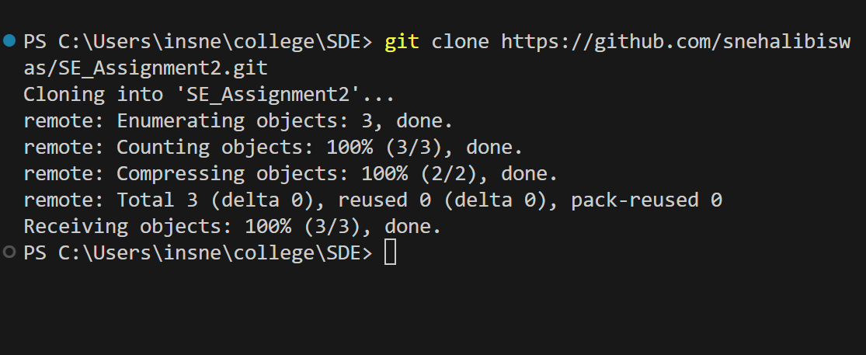

Repository Cloned Successfully

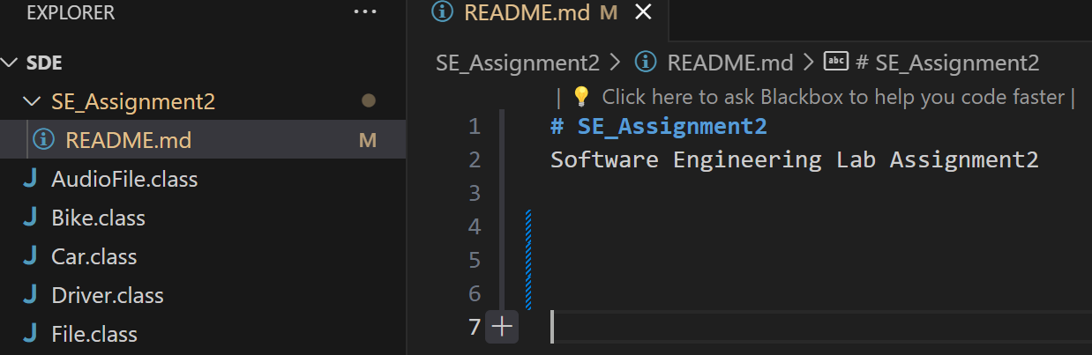

Open ReadMe file and update it

Click on Commit to commit changes to repository

Changes successfully committed

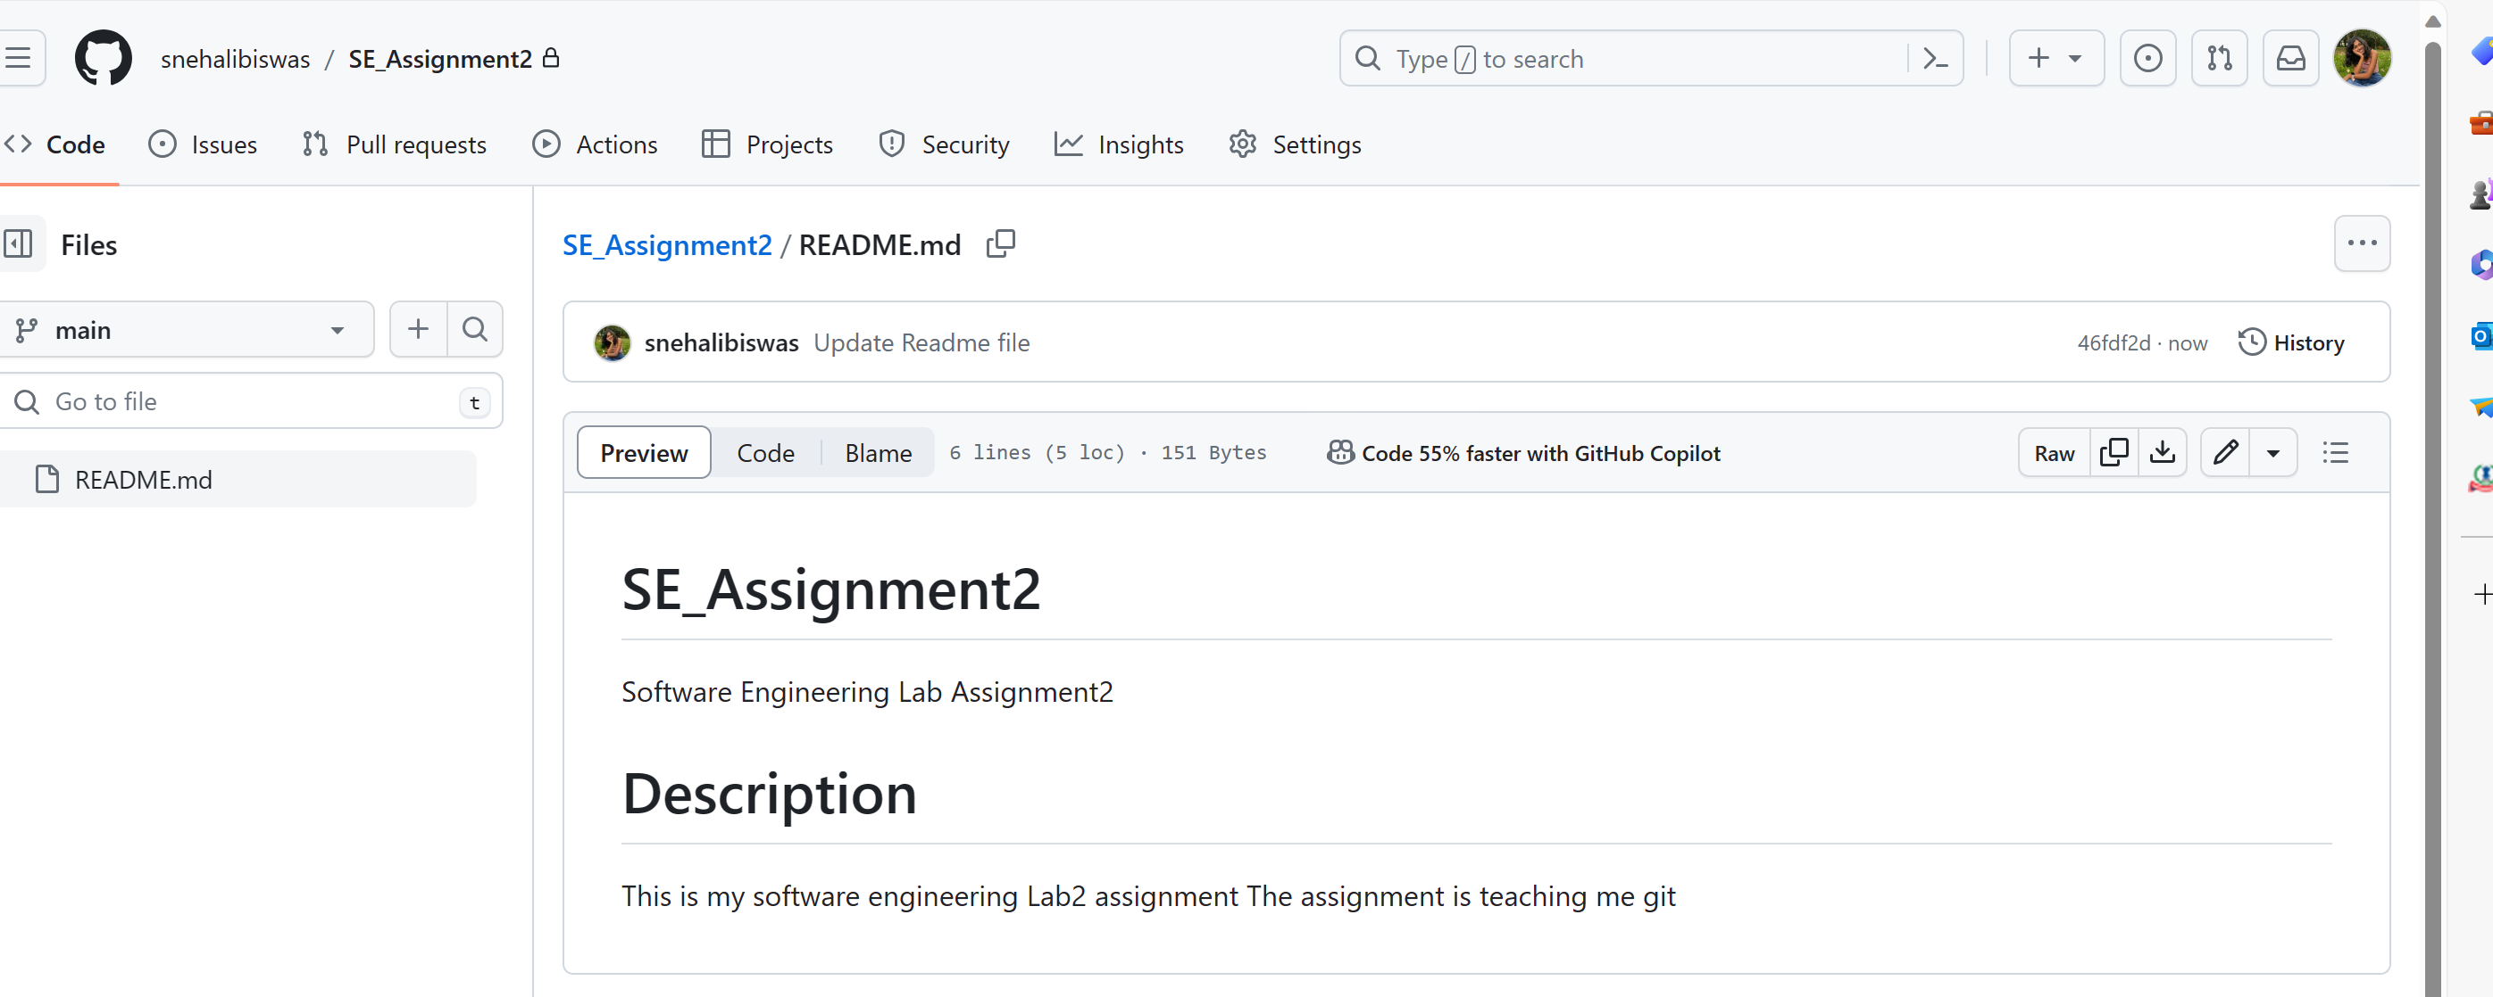

Creating new branch:-

View-> Command Palette -> Git Checkout -> Create New branch-> New branch name



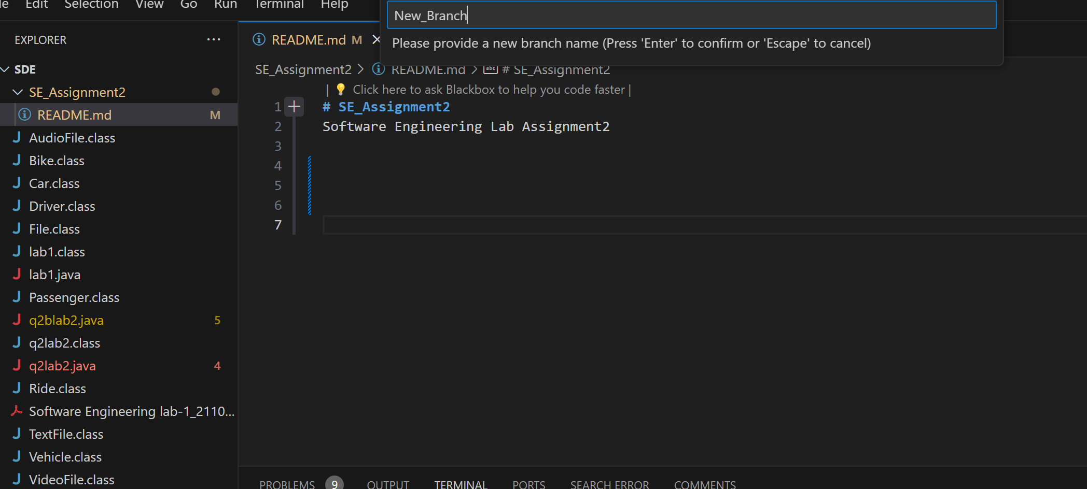

New branch created successfully

Coping to new branch

Copied to new_branch successfully

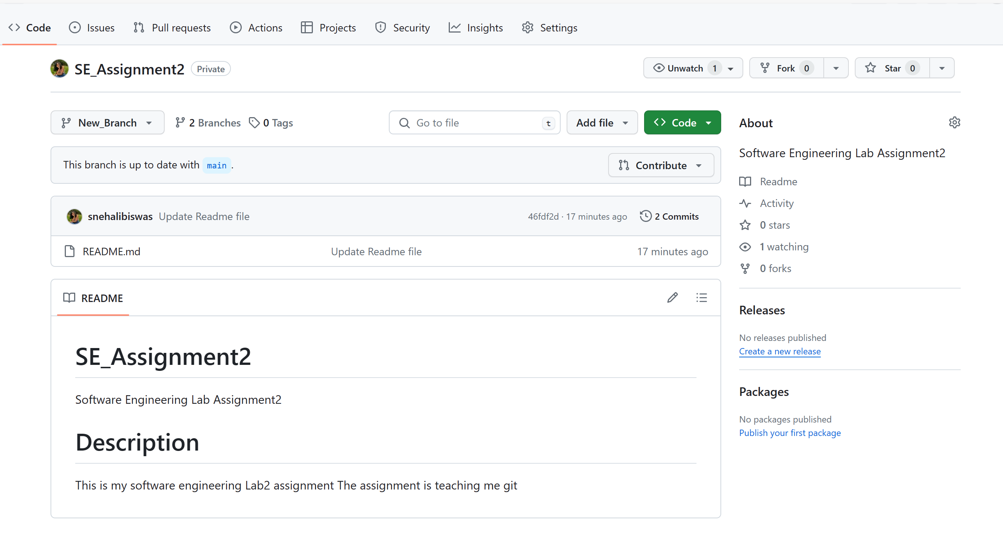

Creating python file on VSCode

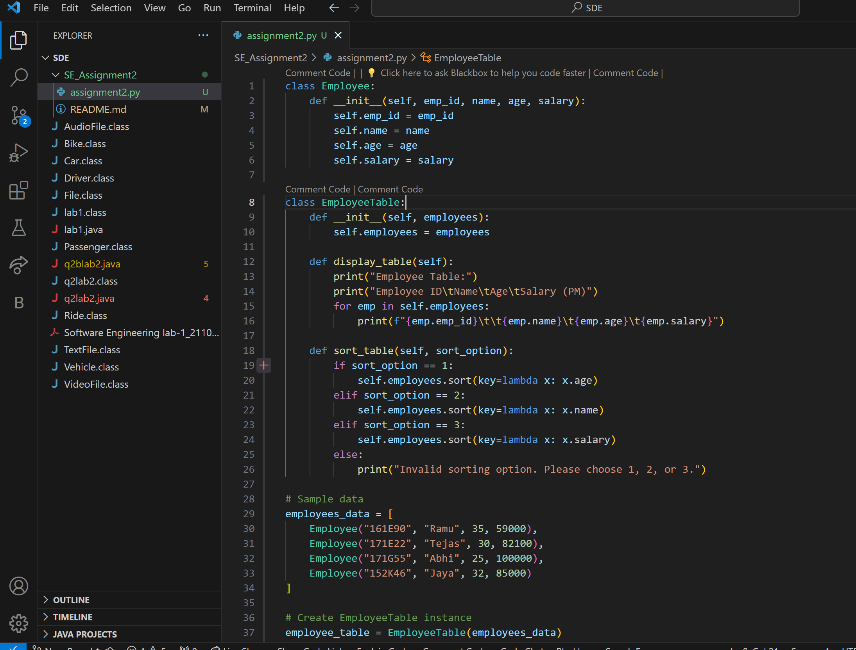

Push Python file to new_branch

Pushed successfully to new_branch

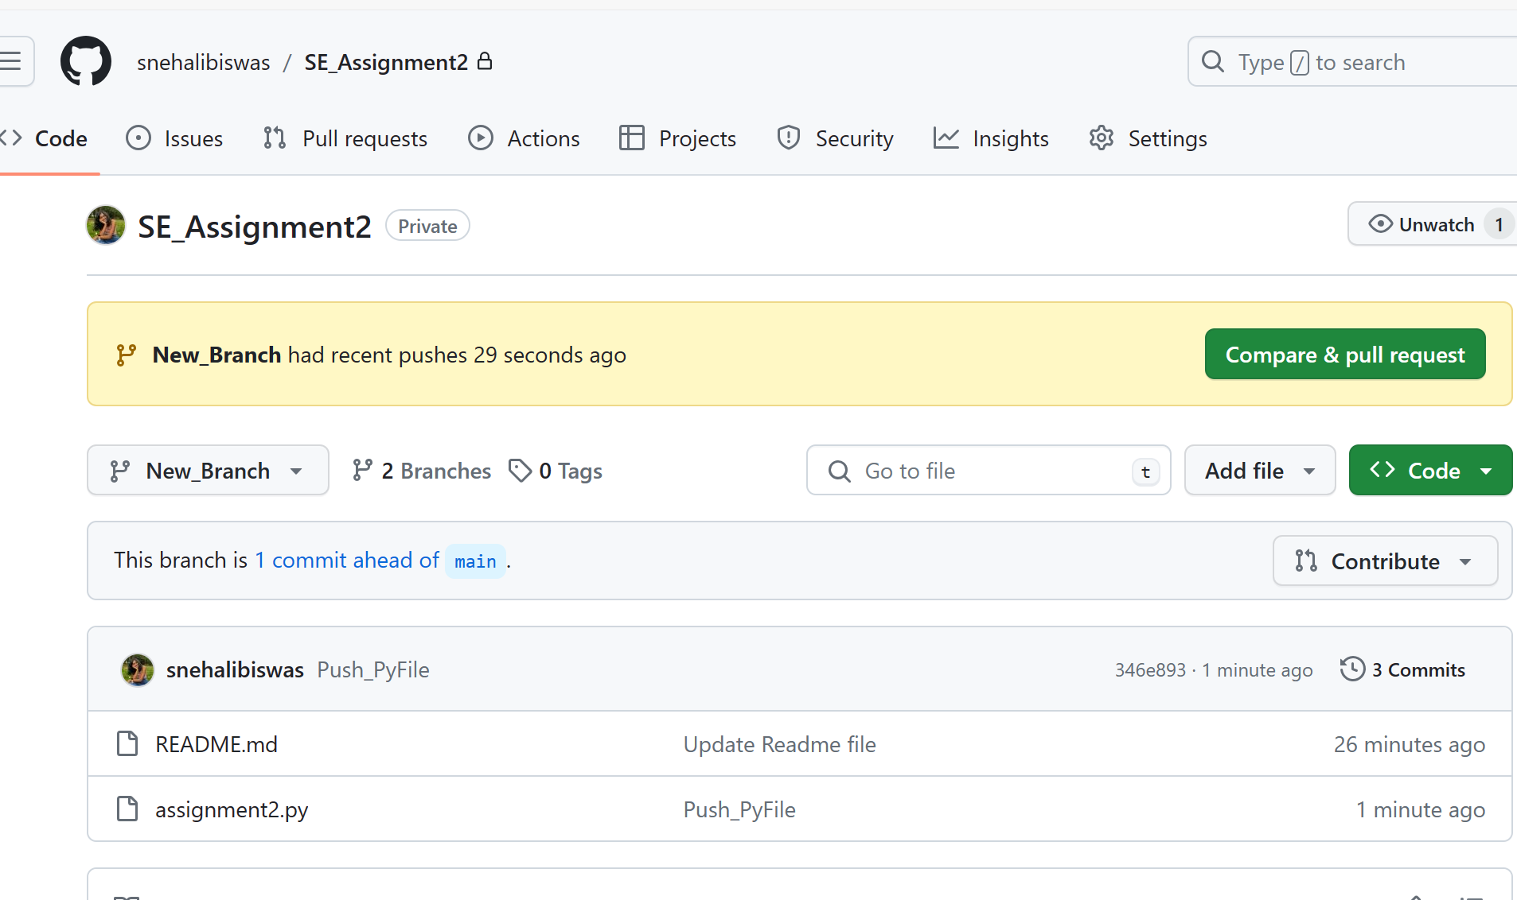

However Python file not their in main branch

Merge the two files:-

Checkout to main branch successful

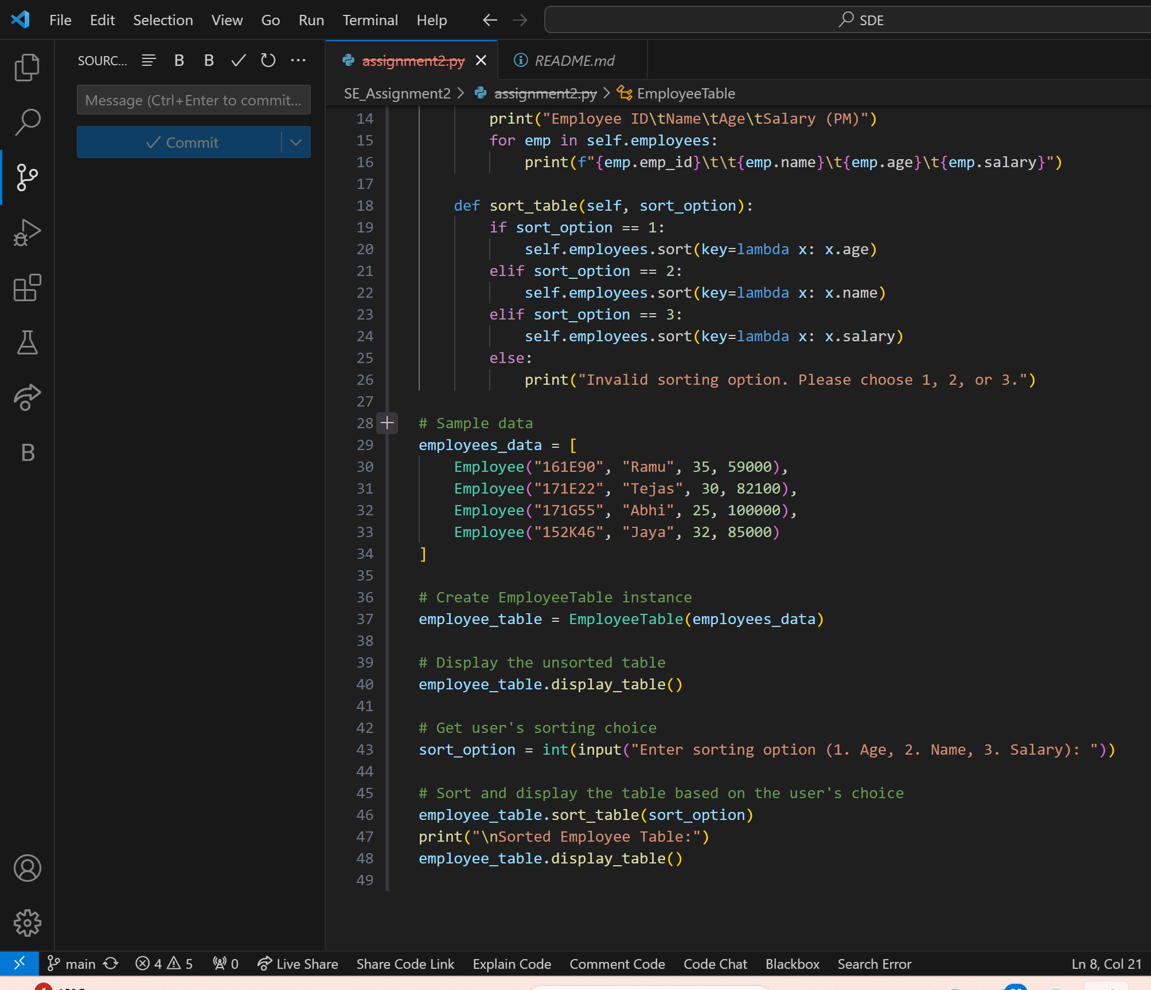



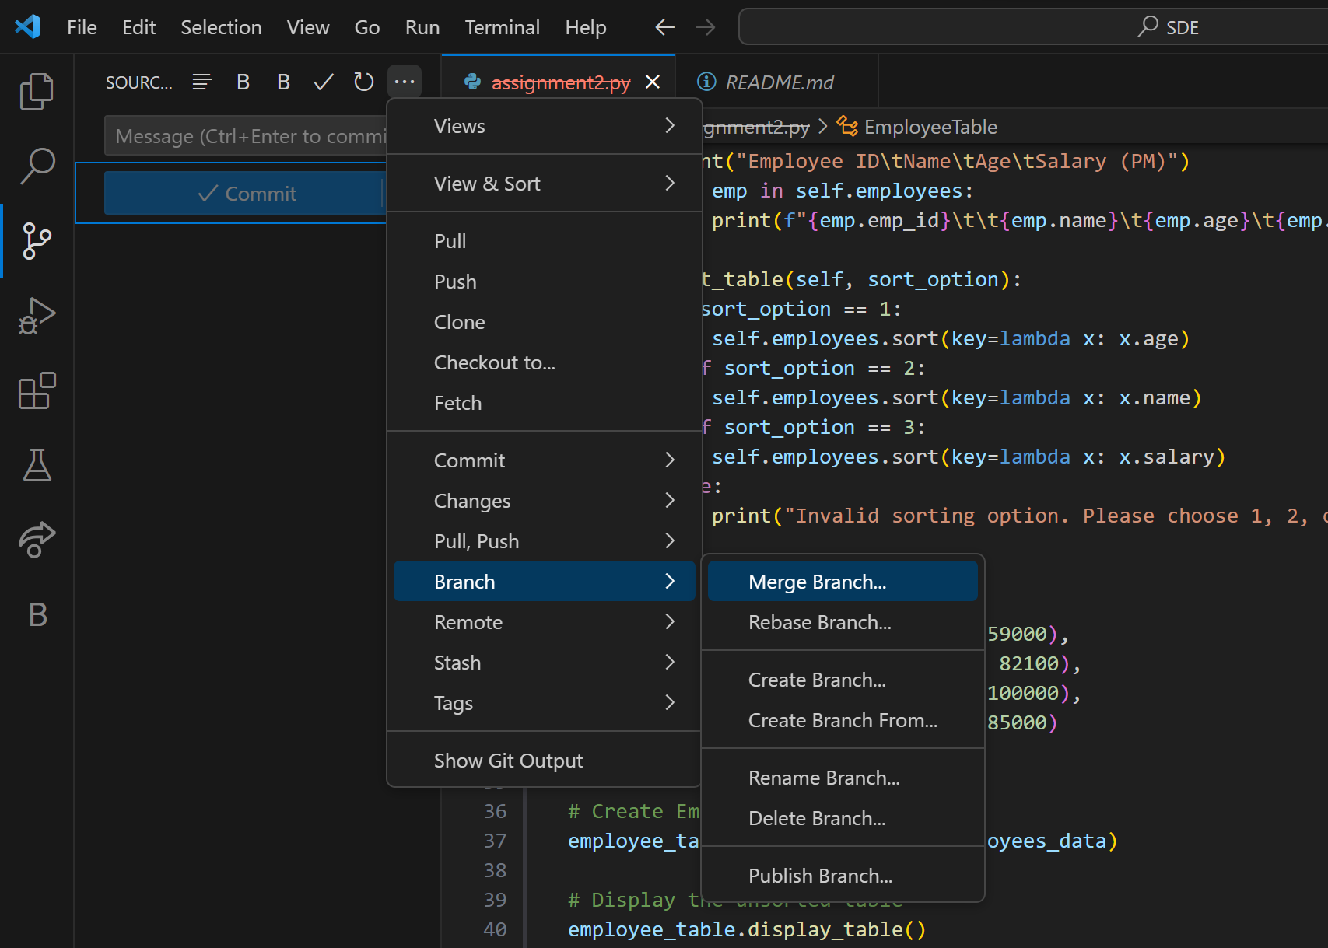

Select new_branch and Sync Changes.

Two branches merged successfully

